**SHORT ANSWER QUESTION**

**Question 1** (3 marks)

On hot summer days at the beach you can sometimes see people relaxing on a deck chair with a wet cloth over their forehead. Referring to heat energy concepts, explain how a wet cloth placed on the forehead can help a person stay cool.

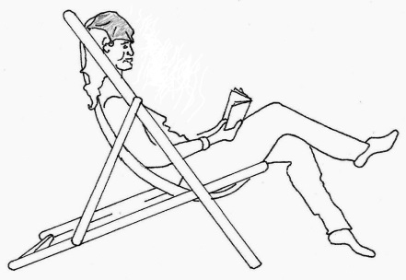

Wet Cloth

**Question 2** (3 marks)

A blacksmith heated a 950 g stainless steel horseshoe in a furnace until it reached a temperature of 749°C. He plunged the horseshoe into 3.20 L of water. The final temperature of the steel and water mixture was 43.3°C when they reached thermal equilibrium.

Calculate the energy that transferred out of the horseshoe into the water.

**Question 3** (4 marks)

A sample of skull bone from a recently deceased human was tested and found to have an activity of 0.320 Bq. A similar size sample was obtained from a human skull uncovered at an archaeological site and its activity was measured. Over a one hour period 324 counts were registered on a Geiger counter. The half life of radioactive carbon is approximately 5730 years.

(a) Determine the activity (becquerels) for the archaeological sample.

(1)

(b) Determine the age of the skull from the archaeological site.

(3)

**Question 4** (4 marks)

Write balanced nuclear equations for the following decays:

1. Sodium-24 (Na-24) by beta negative decay.
2. Thorium-232 (Th-232) by alpha decay.

**Question 5** (4 marks)

Fill in the blanks to complete the following sentences:

1. Heat transfer by the process of radiation is primarily by the ____________________ portion of the electromagnetic spectrum.
2. The process of heat transfer within the atmosphere above a desert that leads to wind formation is called ______________________
3. Heat loss by the process of __________________ from a thermos flask can be minimized by the silvered (mirrored) glass wall in the flask.
4. The air pockets trapped between the fibres of a woollen jumper minimize heat transfer because air is a poor ____________________________ of heat.

**Question 6** (3 marks)

Wine glass

Cracks in the glass where it has come into contact with hot water

If a thin walled drinking glass (such as a wine glass) is dipped into very hot water the glass often cracks.

Referring to the principles of Kinetic Molecular Theory, explain why this happens.

**Question 7** (4 marks)

1. Explain why the metal copper is a better electrical conductor than rubber. (2)
2. Explain why the metal copper is a better heat conductor than rubber. (2)

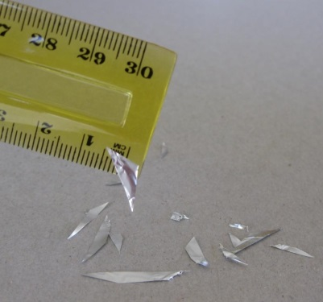**Question 8** (4 marks)

A plastic ruler is rubbed with a cloth so that it becomes negatively charged.

The ruler is brought next to some small pieces of aluminium foil.

The pieces of aluminium are attracted to the ruler and ‘stick’ to it.

1. Explain how the ruler can become negatively charged. (2)
2. Explain, with reference to electrostatic principles, how the aluminium pieces can ‘stick’ to the ruler. You can use the picture to assist your answer.

(2)

**Question 9** (4 marks)

One possible fission reaction of Uranium-235 proceeds as follows:



Mass of Rubidium-95 nucleus: 94.909022 u

Mass of Caesium-137 nucleus: 136.876912 u

All other masses are on the data sheet provided

Calculate the energy released in this reaction. You must work in atomic mass units and electron volts for this question.

**Question 10** (4 marks)

When a patient receives nuclear medicine treatments in a hospital, their absorbed dose must be carefully monitored.

1. Explain why nuclear radiation can be harmful to the human body.

(2)

1. A ‘quality factor’ is applied to different types of radiation. Explain why.

(2)

**End of Section One**

**EXTENDED ANSWER TYPE**

**Question 1 [12 marks]**

1. Some liquid alcohol of mass 0.65 grams was placed in a glass container and vaporised at 70ºC. The container with the vapour was placed in a large water bath that was kept at room temperature. The change in temperature of the alcohol was recorded for 1 minute. There was **constant rate of energy output from the alcoholic substance** such that 1165 J of energy was transferred out in a **50 second** time period. The graph below shows the *cooling curve* produced. Assume that heat loss to the surroundings was negligible.

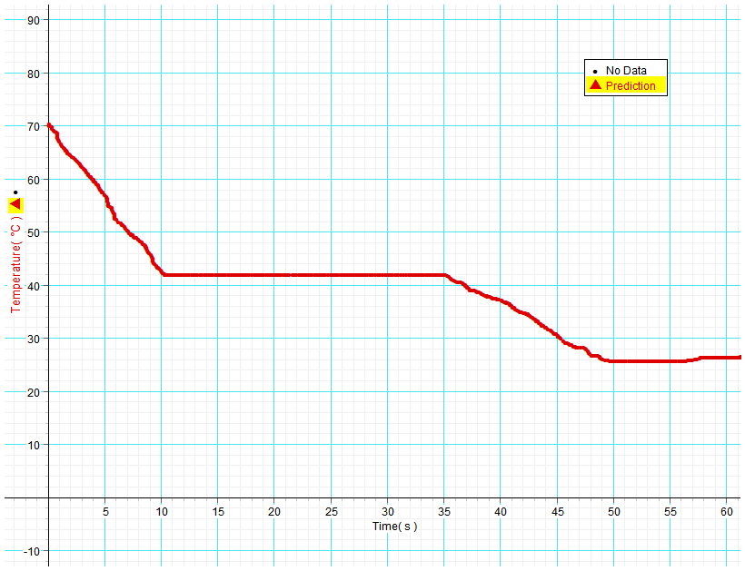

**A**

**B**

**C**

**D**

Cooling curve of alcoholic substance.

1. From the graph, what comparison can you make between the specific heat capacity of the liquid alcohol versus the specific heat capacity of its vapour? *No calculation is required.*

(2)

1. What states of matter are present in the container during section BC? (1)

iii) Determine the latent heat of vaporisation of the alcohol. (3)

iv) In terms of the Kinetic Molecular Theory, explain why the temperature of the substance did not decrease while energy transferred from it to the water between 10 and 35 seconds. Define **temperature** as part of your answer. (3)

1. Consider ‘0.65 g of the vapour at 70°C’ and ‘10 kg of the liquid at 25°C’. Which of the two would you expect to have the highest internal energy? Discuss with reference to Kinetic Molecular Theory. (3)

**Question 2 [13 marks]**

The graph below shows the binding energy per nucleon versus mass number for the nuclei of some common isotopes.

Mass Number A



Binding Energy per Nucleon (MeV)

1. In which nucleus do the protons and neutrons have the lowest mass? Circle the best response.

(1)

A. Constant mass in all nuclei B. Hydrogen-1 C. Lithium-6

D. Iron-56 E. Uranium-235 F. Uranium-238

1. From the graph estimate the average binding per nucleon (MeV) of the Lithium-6 nucleus.

(1)

1. Use your previous answer and data from the constants sheet to estimate the difference in mass between a Lithium-6 nucleus and the individual nucleons that go into making the nucleus. State your answer in atomic mass units.

(2)

1. Refer to the graph to explain which elements can undergo nuclear fusion and release energy. (1)
2. There are several possible reactions that are being considered for nuclear fusion power plants in the future. One of them is the fusion of deuterium and lithium-6.



Mass of lithium-6 nucleus: 9.98561 × 10-27 kg

1. Calculate the energy (joules) released by this reaction. *You must keep your units in kg and joules for this question*.

(4)

1. Convert the energy you have calculated in joules to MeV.

(1)

1. Give 2 reasons why nuclear fusion is ultimately seen as more desirable than fission.

(2)

1. In what way is a nuclear power station similar to a power station that burns coal to produce electricity?

(1)

**Question 3 [13 marks]**

A group of engineering students are studying the rate of energy emitted by heat radiation from an engine block. They are able to detect the amount of radiation transmitted from the engine by sensors placed on the walls, floor and ceiling of the test room.

The engine block is heated to a given temperature and the power (or energy emitted per second) is measured. The students have recorded sets of data for temperature (K) and Power (W) in the table below.

Engine block of surface area A = 0.396 m2

The students are using a simplified version of the Stefan-Boltzmann radiation equation:

e = emissivity (a value from 0 -1 that indicates ability to emit radiation)

P = power (W) T = temperature (K) A = surface area of block (m2)

σ = the Stefan-Boltzmann constant = 5.67 × 10-8 J s-1 m-2 K-4



They have justified the use of this version of the equation because the surrounding walls, ceiling and floor are designed not to radiate energy back to the engine block.

One of the primary objectives is to determine the emissivity value (**e**) of the engine block.

The students decide to graph power on the y-axis versus Kelvin temperature to the power 4 (T4) on the x-axis. This will ‘linearise’ the data into a **y = m.x + c**  format, such that the gradient of the line of best fit equals an average value of ().

|  |  |  |
| --- | --- | --- |
| Temperature (K) | Temperature4 (K4) | Power (W) |
| 360 | 1.68 ×1010 | 290 |
| 400 |  | 435 |
| 440 |  | 640 |
| 480 |  | 900 |
| 520 |  | 1240 |
| 560 |  | 1680 |

Results table:

1. What is the independent variable in this experiment?

(1)

1. Fill in the missing values in the table. (Follow the format of the first value which has been done for you)

(2)

1. Plot your data points onto the graph paper and include all appropriate axes labels and units and draw a straight line of best fit through your data points.

(5)

prac exam youngs mod 10 by 10

1. Determine the gradient of your line of best fit with careful reference to the units on each axis.

(3)

1. Substitute values to determine the value of emissivity **(e)** of the engine block. (If you were unable to determine the gradient of the graph use a value of 1.70 × 10-8)

(2)

**End of Section Two**

**Section Three: Comprehension (14 Marks)**

This section contains **one (1)** question. You must answer this question. Write your answer in the space provided. **Suggested working time for this section is 20 minutes.**

**Solar Cells – converting sunlight into electricity**

In the midst of the debate about global warming and obvious problems such as the disastrous BP oil spill in the Gulf of Mexico this year, alternatives to coal, oil and gas are urgently sought. Clean, renewable energy is a vision shared by many.

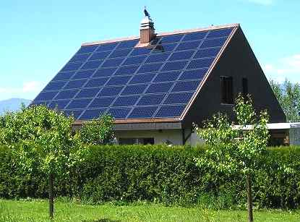An energy source that is increasingly viable is from Solar Cells that convert sunlight into electricity. You may have seen arrays of solar panels on rooftops in Perth. So how do they work?

A basic explanation is as follows. The solar cell consists of 2 thin layers of a semiconducting material such as silicon which have different electrical properties. Many cells are spread over a large surface area in a panel. Sunlight shines onto the panel and light energy is transferred into electrons within the silicon. These electrons can be driven through an external load with the solar panel acting as a source of emf.

The electrical conduction properties of a semiconductor such as silicon are altered by adding impurities in a process known as ‘doping’. An n-type semiconductor is made by adding atoms such as arsenic which give the semiconductor an excess of free electrons. A p-type semiconductor is doped with materials such as aluminium or indium which give the semiconductor a deficiency of electrons known as ‘holes’.

Load resistor

A thin upper layer of n-type semiconductor is bonded to a layer of p-type semiconductor

n-type material

p-type material

electrical contacts

Electrons from the n-type material fill into holes of the p-type material near the junction

Atomic electrons energised by sunlight follow an external path from n to p

Consider a solar cell when no sunlight shines on it. At the junction between the n-type and p-type materials, electrons from the n-type migrate into the holes of the p-type, this leaves the n-type layer with a net positive charge and the p-type layer with a net negative charge. An electric field is established across the junction. The field strength increases until equilibrium is reached making it harder for electrons to cross from the n-side to the p-side. Now the electric field behaves like a ‘diode’ which only allows other electrons to cross in the direction p to n.

When sunlight shines onto the solar cell, a photon of light absorbed near the junction can free an electron in the atomic structure and leave a positive hole. This free electron is forced across the junction to the n-type layer and the hole effectively moves to the p-type layer by successive electrons filling the hole but forming another hole where they came from. If an external conducting path with a load resistance is connected between the n-type layer and the p-type layer then electrons will flow from the n-type layer through the external path and back to the p-type layer to fill into a hole.



Pmax

The graph shows the typical electrical output characteristics for a solar cell in Perth. The maximum power for ‘January full sunlight’ is indicated by Pmax.

Maximum power from a solar cell is achieved by carefully setting the load resistance. When load resistance is too high a high voltage can be achieved but only with very low current. A low resistance can maximise current but the voltage will be much lower.

When purchasing solar panels there are important factors to consider. The high cost means that it can take many years to payback the financial outlay. Reliability is critical although many manufacturers now offer a 25 year warranty. The cells supply DC but household items run on AC so an ‘inverter’ is needed for the conversion. Western Power like many other utilities will now buy excess electricity produced by a solar powered household, so this, along with government subsidies, can make a purchase feasible.

**Questions**

1. Explain how a semiconductor such as silicon can be made to have an excess of free electrons.

(2)

1. What is the net electrical charge of a ‘hole’? *Circle the correct response.* (1)

A. Neutral B. Positive C. Negative D. Positive or negative depending on location

1. Explain how a ‘hole’ can effectively move through the atomic structure of silicon.

(2)

1. Use the graph to estimate the maximum power output of a solar cell in January full sunlight. Clearly indicate how you obtained data from the graph.

(3)

1. *Refer to the 3 curves on the graph for this question and circle the best response.*

For an output voltage of 0.1 V the load resistance is -

(1)

A. Too high in all cases B. Too low in all cases

C. Could be either depending on sunlight D. Impossible to determine

1. Solar panels supply DC. What problem does this cause when feeding electricity back to the Western Power grid and how is this problem solved?

(2)

1. A typical solar panel is 18% efficient in terms of converting the energy in sunlight to electrical energy. Calculate the amount of solar energy required per second for a solar panel with an electrical output of 432 W.

(3)

End of questions